**

*Shaheed Zulfikar Ali Bhutto Institute of Technology*

*Introduction to Computer Science*

*Project Report*

*January 2, 2024*

Instructor: Sadia Aziz

By-

Deepa

Alisha Anwar

Syed Raza Ali

ACKNOWLEDGEMENT PAGE

We begin by expressing our deepest gratitude to our families, whose unwavering support and understanding have been the bedrock of our journey in completing this project report on Introduction to Computer. Their encouragement and sacrifices have been invaluable, and we are truly grateful for their constant presence.

We extend our heartfelt thanks to Miss Sadia Aziz, our project guide, for their guidance, expertise, and continuous support. Their mentorship played a pivotal role in shaping the direction and success of our collaborative effort.

Special appreciation goes to Syed Raza Ali and Deepa, our fellow group members, for their dedication and collaborative spirit. Each team member brought unique skills and perspectives to the project, contributing to its overall success.

We are also grateful to Alisha Anwar, for her specific assistance in doing the whole project. Their expertise significantly enriched the quality of our work.

Acknowledgment is due to our classmates and friends for their valuable insights, suggestions, and encouragement during the course of this project.

Our thanks extend to the library staff and online resources for facilitating access to essential reference materials and literature crucial for the project.

This project is a collaborative effort, and we are genuinely appreciative of the contributions of all those mentioned above.

Alisha Anwar

Deepa

Syed Raza Ali 2-January-24

ABSTRACT

As we start our project, our goal is simple: make a website that's easy and nice to use. We're using HTML for the main parts, like headers and footers, and CSS to make it look good on different devices.

We picked designs that people will like, such as a special wheat-colored header for the "Best Seller" and a cool half-image section. The navigation bar is in a good spot so people can find things easily.

The part showing products is organized neatly, with details and an easy "ADD TO CART" button. Pictures from other places make our site look even better.

We added helpful sections and a footer with extra details and contact info. CSS helps us get the layout just right.

In a nutshell, our project shows how HTML and CSS work together to make a good-looking and easy-to-use website. We've learned a lot, and these skills will be handy for future web projects.

Table of Contents

1. **Introduction 05**
2. **Background 07**
3. **Working of Project 08**
4. **Scope of Project 09**
5. **Conclusion 10**

CHAPTER 1: INTRODUCTION

HTML (Hypertext Markup Language):

HTML serves as the structural foundation of a webpage. It uses a series of elements, enclosed in tags, to define the various parts of a webpage. Here are some key HTML concepts:

1. Document Structure:

- HTML documents start with a declaration: <!DOCTYPE html>. This sets the document type and version.

- The root element is <html>, containing two main sections: <head> (title) and <body> (content).

2. Head Section:

- <head> includes the <title> tag inside that sets the title of the webpage.

3. Body Section:

- <body> contains the content of the webpage.

- Elements like <h1> to <h6> represent headings, <p> for paragraphs, <ul> and <li> for unordered lists.

CSS (Cascading Style Sheets):

CSS complements HTML by providing styles that control the presentation and layout of HTML elements. Here are key CSS concepts:

1. Selectors:

- CSS uses selectors to target specific HTML elements for styling.

- Examples include element selectors ( body , h1 ), class selectors ( .my-class ), and ID selectors ( #my-id ).

2. Properties and Values:

- CSS properties define the aspects of styling (e.g., color , font-size ).

- Values are assigned to properties to determine the specific styling (e.g., #333 for color, 16px for font size).

3. Box Model:

- Every HTML element is considered a box with properties like margin, padding, border, and content .

- These properties control the spacing and layout of elements.

4. Backgrounds and Colors:

- CSS enables setting background colors ( background-color ) and text colors ( color ).

- Colors can be defined using keywords, hex codes ( #4CAF50 ), or RGB values.

5. Font Properties:

- CSS provides properties like font-family to set the typeface and font-size for text size.

By combining HTML's structure with CSS's styling capabilities, web developers create visually appealing and organized web pages. HTML defines the content and structure, while CSS enhances the presentation, ensuring a positive user experience.

CHAPTER 2: BACKGROUND

1. Initialize HTML Document.

2. Open the head tag and set the title of the webpage. - Open the style tag for internal CSS.

3. Open the body tag.

- Create a container div for the top header - Inside the container, add a div for the "Best Seller" text.

4. Create a navigation bar using the nav tag.

- Inside the nav tag, add a div for the logo - Include an image for the logo and a span for each part of the brand name.

5. Create a div for the half-image section. - Include an image and a button for exploration.

6. Product Display

7. Create a div for additional informational divs. - Create a footer with copyright information.

8. Close HTML Tags:

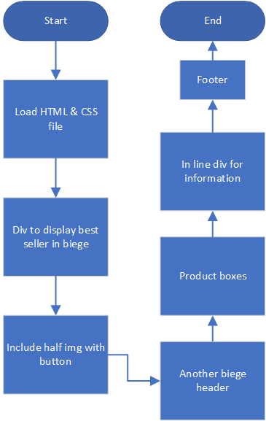

CHAPTER 3: WORKING OF PROJECT

* The brand is recognized for its quality fabrics, vibrant designs, and a wide variety of choices for customers.​
* Alkram Studio's website likely offered an online platform where customers could explore and purchase their products.​
* The website would typically feature sections dedicated to different product categories, such as clothing for men, women, and children, as well as fabrics and home textiles.​

The provided HTML and CSS code outlines the structure and styling of a webpage. Beginning with the document type declaration <!DOCTYPE html>, the HTML document is structured with the root element <html>encompassing the entire content. In the head section, links to external resources are specified. The title of the webpage is defined as "Alkaram Website."



The body section encapsulates the main content and styling of the webpage. The layout starts with a wheat header <div id="top-header"> for highlighting "Best Seller." The navigation bar <nav> features links to different sections along with a logo. A visually engaging half-image section <div id="half-image"> includes a captivating image and an exploratory button. Two rows of product boxes <div class="item1"> showcase various items with images, descriptions, prices, and an "ADD TO CART" button. 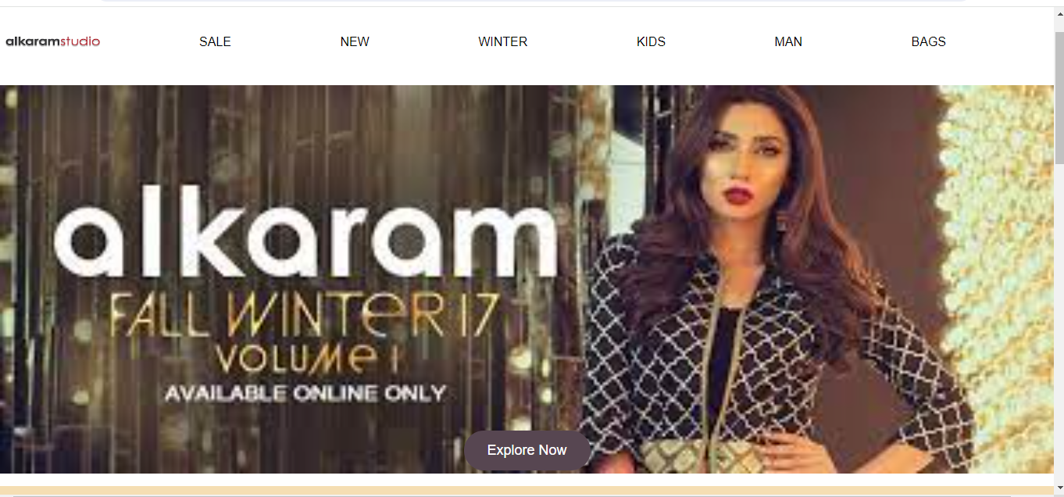

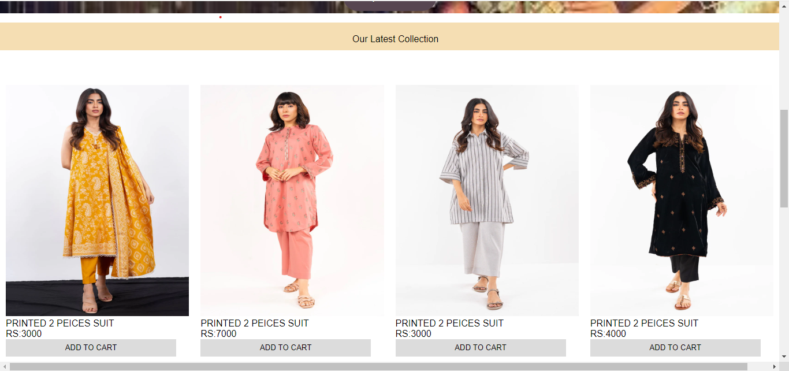

Additionally, a div with inline divs <div id="inline-divs"> is employed for presenting information, customer care details, and contact information in a neatly arranged format. The footer <footer> serves as the conclusion, displaying a copyright notice and signifying the end of the webpage.

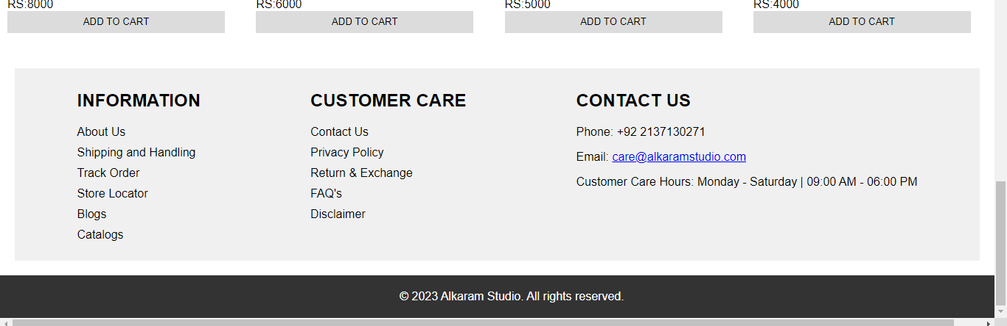

Throughout the code, embedded CSS styles enhance the visual appeal and layout, providing specific instructions for styling elements such as the body, header, logo, navigation bar, product boxes, and footer. The usage of comments aids in explaining the purpose and functionality of individual sections, contributing to the overall clarity and maintainability of the code. External resources, indicated by image source references, supplement the code with visual content. Collectively, this HTML and CSS code forms the foundation for a well-structured and aesthetically pleasing webpage.​

CHAPTER 4: SCOPE OF PROJECT

Our project does more than create a cool webpage. Here's what it covers:

1. Easy for People:

- We made sure our webpage is simple and looks good so everyone can use it easily.

2. Learn Something New:

- Our project helps people learn about making webpages using HTML and CSS. It's like a web development lesson.

3. Show What We Can Do:

- We wanted to show we know how to use HTML and CSS to make things look nice on the internet.

4. Ready for More Stuff:

- Our project can be a starting point for making other cool things on the internet. We can add more features in the future.

5. Maybe for Selling Things:

- We set up our webpage so it could be used for selling stuff online. Like a little online store.

6. Add Pictures Easily:

- We can easily put in pictures from other places to make our webpage look even better.

7. Keep Learning New Stuff:

- Our project reminds us that we always need to learn new things, especially in tech. It's a journey that never stops.

CHAPTER 5: CONCLUSION

In wrapping up our project report, we've successfully created a good-looking webpage using HTML and CSS. Our main goal was to make a website that's easy for users to interact with. The webpage has a well-organized structure, making it easy for people to move around and enjoy their time here.

HTML helped us set up the main framework of our page. It defined important parts like headers, navigation bars, pictures, and footers. On the other hand, CSS played a big part in making our webpage look nice and work well on different devices.

We made careful choices in our design, like using a special wheat-colored header to showcase the "Best Seller" and creating an interesting half-image section with a button to explore. The navigation bar is in a smart spot, making it simple for users to find their way around.

The product display section, arranged in two rows of boxes, shows various items with details and an easy "ADD TO CART" button. Adding pictures from outside sources made our webpage more visually appealing, highlighting how important pictures are in modern web design.

We also included informative sections in a neat layout, along with a footer that has extra details and contact information. This makes sure users have more resources and ways to get in touch, making their experience even better. Using flex properties and positioning in CSS helped us get the layout and responsiveness just right.

To sum up, our project proves that using HTML and CSS can create a good-looking, working, and user-friendly webpage. We've learned a lot about how web development works, covering things like structuring documents, styling, and designing layouts. As technology keeps advancing, the skills we've gained from this project will surely be helpful in future web development adventures.

CHAPTER 6: REFERENCES

Introduction to Computer Science, Szabist.

Google

Artificial Intelligence